JEREMIAH NYAGAH NATIONAL POLYTECHNIC

ELECTRICAL AND ELECTRONICS DEPARTMENT
AUTOMATE AN ELECTRICAL MACHINE

PRACTICAL ASSESSMENT

50 MARKS

Qualification Code: 071306T4EEN
Qualification: Electrical Engineering Level 6
Unit Code: ENG/OS/PO/CR/05/6
Unit of Competency: Automate an Electrical Machine
INSTRUCTIONS TO THE CANDIDATE
- Time allocated: 3 hours.
- Use provided plain paper for drawings.
- Assessor will record performance via audio-visual means.
- Comply with I.E.E regulations.
Resources Provided:
- PLC (1)
- Start/Stop buttons (NO/NC)
- Magnetic valves (MV1, MV2)
- Agitator motor (M)
- Level transmitters (LT1, LT2, LT3)
- 4.0 mm² & 1.5 mm² PVC cables (Red, Black, Yellow/Green)
- Mini-trunking, screws, multimeter
- Installation board (1m x 1m)

Problem: Mixing Process Automation
System Description:
Automate a tank mixing process (Figure 1) where:
- Start button opens MV1 (water inlet).
- At LT2: Close MV1, start agitator (M) and conveyor motor.
- At LT3: Stop conveyor, open MV2 (outlet).
- Below LT2: Stop agitator. Cycle repeats when Start is pressed again.
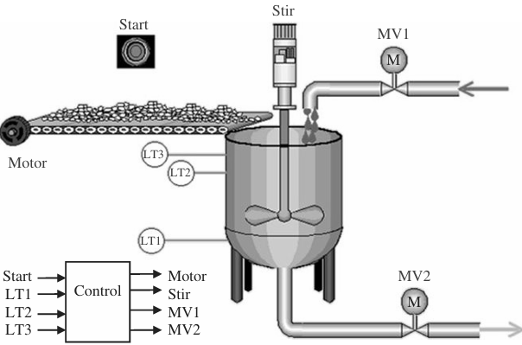
Figure 1

TASKS

TASK 1: Design (7 Marks)
- Draw:
  - Block diagram of the system.
  - Wiring diagram (PLC, valves, motors, sensors).

TASK 2: PLC Programming (15 Marks)
- Write a ladder logic program to:
  - Use Start to initiate the cycle.
  - Control valves/motors based on sensor inputs (LT1–LT3).
  - Ensure agitator stops only when level < LT2.
- Label all operands

TASK 3: Simulation (10 Marks)
- Simulate using software to verify logic.

TASK 4: Hardware Installation (10 Marks)
- Mount components on the board per your design.
- Secure wiring in trunking.

TASK 5: Testing (8 Marks)
- Download the program to the PLC.
- Test:
  - MV1 opens/closes with Start/LT2.
  - Agitator starts at LT2, stops below LT2.
  - MV2 opens at LT3.

